**Kubernetes** by google

**Docker Swarm** by docker

**Marathon** by Apache Mesos. These are the top 3 container orchestration tools in the market

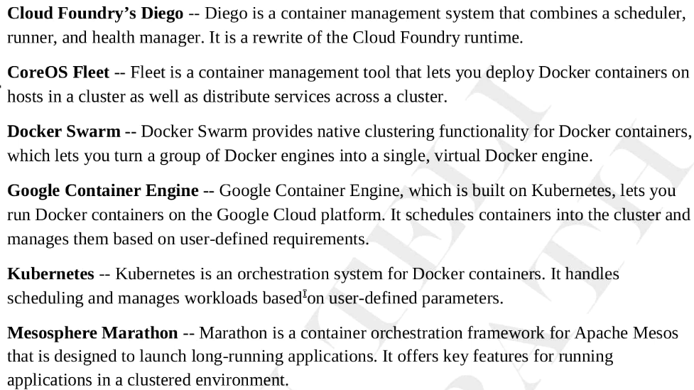

* Suppose we have more than 100 nodes on web server, how do we interact with them? How to know all of them running. Here we use kubernetes
* If something gone wrong, don’t try to correct it

**Example,** if something gone wrong due to memory insufficiency. Bring another container which has memory

* We will never tell how to do to, we tell what we want for example we want 4 web servers
* So, we would be writing a standard package format called manifest, in that we would be writing certain details what we want
* And we give it kubernetes then it makes it happen
* We are going to work on yaml or json file format

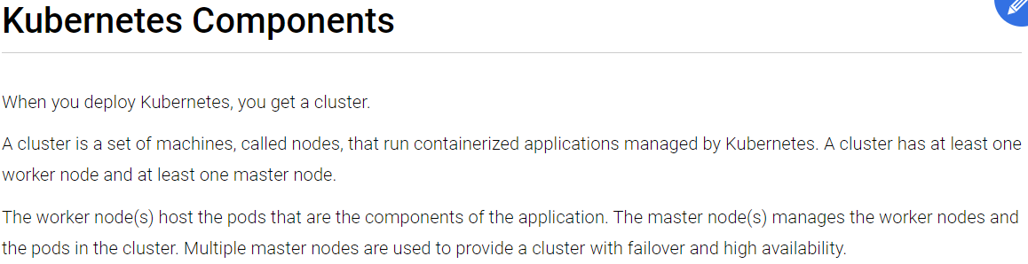

* Orchestration job is to manage the things, like what should go where and when should go etc.
* Our package or manifest will be given to master and master will get the job done on nodes
* Masters (Kubernetes control plane)

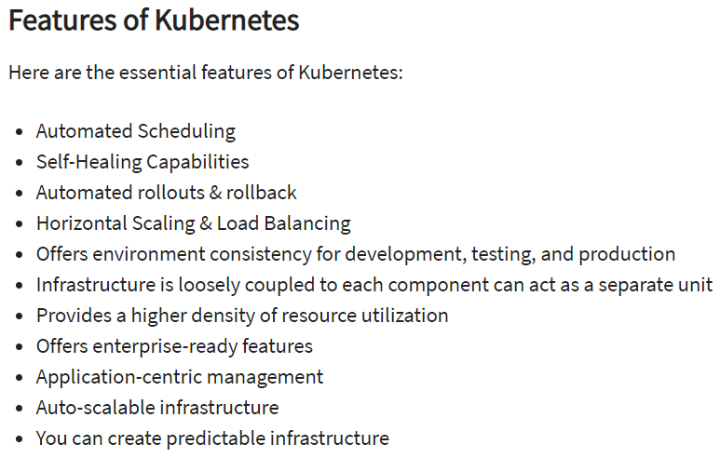

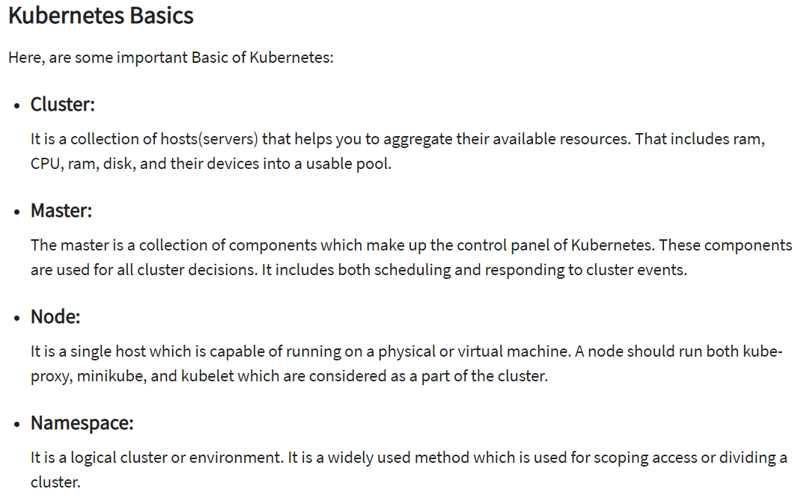

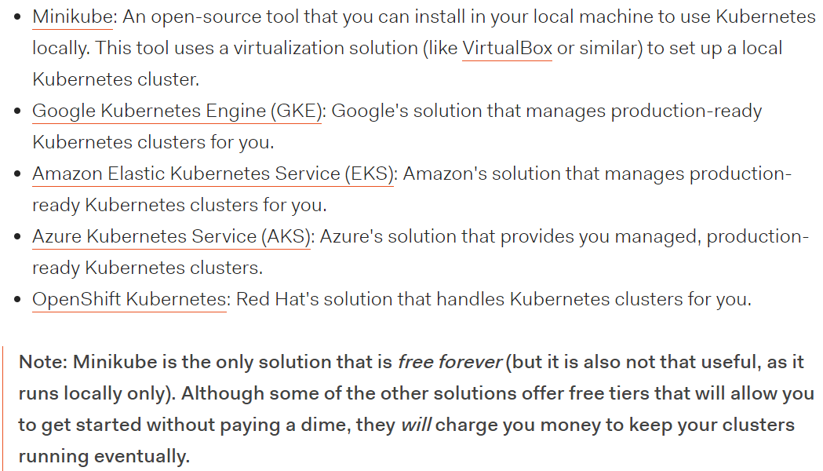

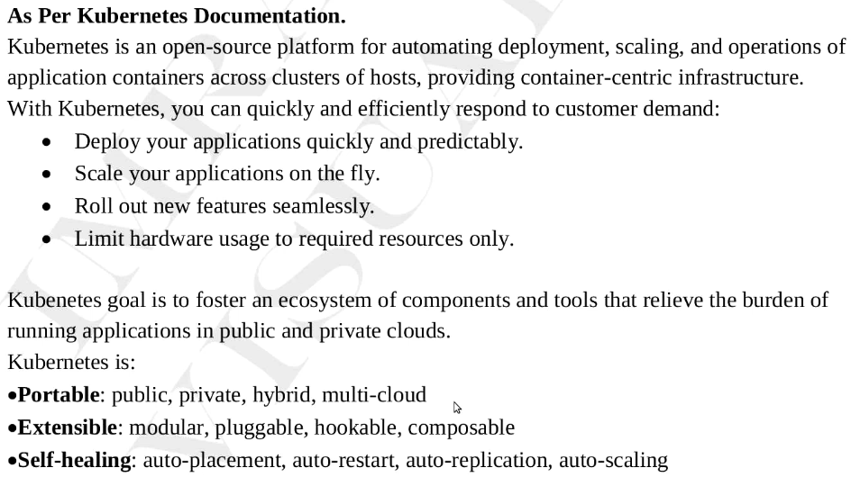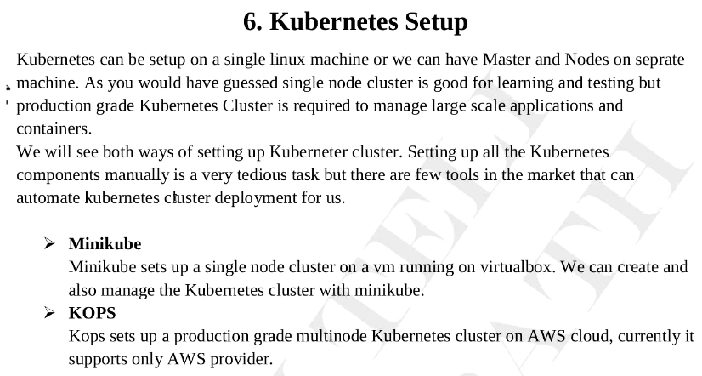

* Minikube is used to setup the testing. All the services in one node like api server, docker engine, kubelete etc in single node
* KOPS and kubeadm used to setup production environment